2017
Ladies of Charity
Designers’ Showhouse
Monday, April 24th – 10:30 am to 1:30 pm
Tour, Box Lunch, Boutique and Raffle

Benefitting non-profit groups for the underprivileged and uninsured including
Duchesne Clinic, Seton Center and Villa St. Francis

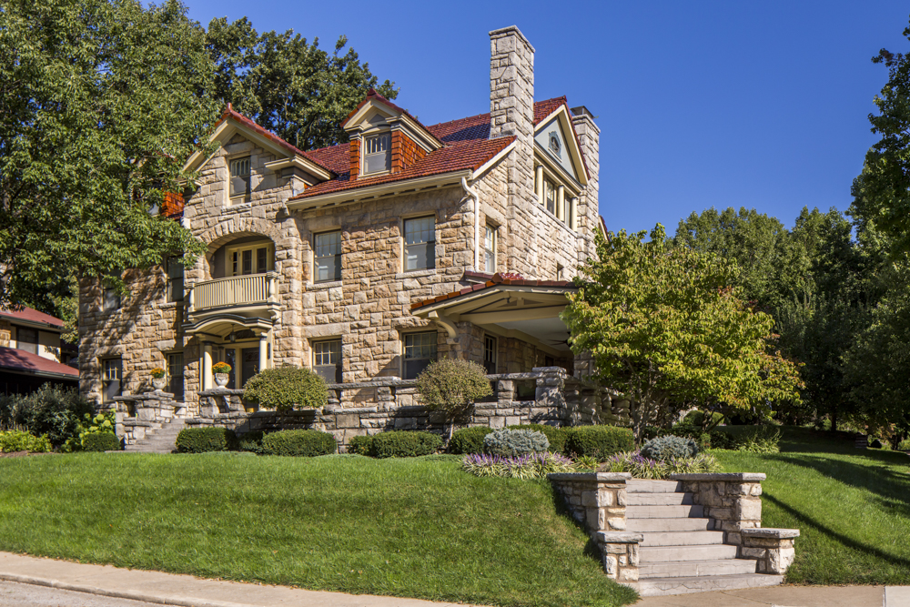

816 Gleed Terrace, Kansas City, Missouri 64109

Information | $30 per person | Mail Reservations to:
Marnie Robinett | Checks payable to | Karen Camarata
(913) 451-2484 | Ladies of Charity | 5508 W. 129th Street
 |  | Overland Park, KS 66209
Advanced Ticket Sales Only! Your check is your reservation!
ALL RESERVATIONS MUST BE RECEIVED BY APRIL 15th
Cut here and send stub with Check for Reservation- Tour and raffle tickets may be purchased at the Board and General Meeting as well.
_ _ _ _ _ _ _ _ _ _ _ _ _ _ _ _ _ _ _ _ _ _ _ _ _ _ _ _ _ _ _ _ _ _ _ _ _ _ _ _ _ _ _ _ _ _ _ _ _ _ _ _ _ _ _ _ _ _ _ _ _ _ _ _ _ _ _ _ _ _ _ _ _ _ _ _ _ _ _ _ _ _ _ _ _ _ _ _ _ _

Name:________________________________________________________________________________
Your Telephone:________________________________________________________________________
E-mail address:_________________________________________________________________________
Individual Tickets: $30 per person_____________# persons:_____________________________________
Unable to attend donations:________________________________________________________________
Unable to attend Raffle Tickets: (1 for $5 / 3 for $10 / 8 for $20): ____________
Lunch preference: 11:00-12:00____ 12:30-1:30____Due to recent KC Symphony tent restrictions, there will be two SEPARATE lunch seatings, which must be honored.

